***-2330-***

In the view from the end, the barrier  
 shield is conditionally not specified

*APPROVED BY:*

*Head of the container freight station. Vostochnaya Stevedoring Company LLC*

*Schulzhenko E.M.*

2016.

*Agreed by:*

Head of Nakhodka-Vostochnaya station. DVZhD. RZhD OJSC

Moiseev E. V.  
2016.

1. Use a universal large-capacity container of 1СС type with a nominal gross weight of 24-30.5 tons with the following internal dimensions: length - 5968 mm, width - 2330 mm, height - 2330-2655 mm.

2. The cargo for transportation must be prepared in such a way as to ensure the safety of train traffic, safety of cargo and container in the process of transportation.

The shipper shall be responsible for the reliability of the fastening materials. The shipper shall be responsible for the reliability of placing and securing the cargo inside the container. The shipper shall be responsible *for the reliability of fastening the cargo to the pallet*.

|  |  |  |  |  |  |  |  |  |  |  |
| --- | --- | --- | --- | --- | --- | --- | --- | --- | --- | --- |
| *Item*  *No.* | Cargo name | *Q-ty*  *pcs.* | *Weight, tons* | *Total weight,*  *tons* | *Overall dimensions of the cargo* , *mm.* | | | *Coordinates of the load center, mm* | | |
| *Length* | *Width* | *Height* | *In length* | *In width* | *In height* |
| *1-14* | Sheet steel in bundles | *14* | *1.462* | *20.468* | *2500* | *1250* | *220* | *1250 + 1250* | *625 + 625* | *110* |
| *15* | Sheet steel in bundles | *1* | *1.958* | *1.958* | *2000* | *1000* | *250* | *1000 + 1000* | *500 + 500* | *125* |
| TOTAL: | | *15* |  | *22.426* |  |  |  |  |  |  |

3. Loading must be done according to the drawing. The cargo in the container must be placed in two stacks in such a way that the projection of the load center of each load lags behind the projection of the longitudinal and transverse symmetry planes of the container at the distances indicated in the drawing. The end wall of the container must be fenced with a shield made of horizontal bar (item 1) and vertical bar (item 2). Bar (item 2) must be attached to the bar (item 1) with nails (item 15), two at each joint. The ends of the Bar (item 1) must fit into the cavities of the corrugations of the side walls of the container. Cargoes No. 1-8 must be laid close to the shield, marking and laying of cargoes No. 9-15 must also be carried out. From the transverse shift, cargo must be secured with thrust frames made of a vertical bars (item 3) and strut rails (stretchers) (item 4). Bars (item 3) and strut rails (stretchers) (item 4) must be fastened with nails (item 15), two at each joint. The frames must be fastened together with a connecting board (item 5). Board (item 5) must be attached to the bar (item 3) with nails (item 14), two at each joint. Between cargoes No.1-8 and No.9-15 there must be installed thrust frames made of vertical bars (item 6) and strut rails (stretchers) (item 7). Strut rail (stretcher) (item 7) must be fastened to the bar (item 6) with nails (item 15), two at each joint. The frames must be fastened together with a drawbar (item 8). Drawbar (item 8) must be attached to the bar (item 6) with nails (item 15), two at each joint. From the longitudinal shift, cargo No. 15 must be secured with frames made of dead stop rails (hurters) (item 9) and strut rails (stretchers) (item 10). Strut rail (stretcher) (item 10) must be attached to the dead stop rail (hurter) (item 9) with with cramp iron (braces) (item 13), two at each joint. From the transverse shift, cargo No. 15 must be secured with dead stop rails (hurters) (item 11) on one longitudinal side. Dead stop rail (hurter) (item 11) must be placed in the spacer between the base of the cargo No. 15 and the fastening frames and fastened with a connecting board (item 12). Board (item 12) must be attached to the dead stop rail (hurter) (item 11) with nails (item 14), two at each joint. The container doors must be fenced with a shield made of a vertical board (item 16) and a horizontal bar (item 1). Bar (item 1) must be attached to the board (item 16) with nails (item 15), two at each joint.

4. Used materials: Specifications (ЦМ-943) dated 27.05.2003 section 1 cl. 6, 10. para. 12. p. 1, 2, 3, 4.

|  |  |  |  |  |  |  |  |  |  |  |  |
| --- | --- | --- | --- | --- | --- | --- | --- | --- | --- | --- | --- |
|  | | | | | *Total:* | | | | *1184* | *1944* |  |
| *16* | Vertical board (pine, spruce) GOST 8486 | | | | *50 х 150 х 1800* | | | *4* | *0.032* | *0 ,054* | *12* |
| *15* | Nails GOST 283 | | | | *D=5-6 mm, l =150 mm* | | | *384* | *0.012* |  |  |
| *14* | Nails GOST 283 | | | | *D= 4 mm, l =100 mm* | | | *196* | *0.004* |  |  |
| *13* | Cramp iron (brace) GOST 283 | | | | *D= 8 mm, l =150 mm* | | | *12* | *0.002* |  |  |
| *12* | Connecting board (pine, spruce) GOST 8486 | | | | *25 х 100 х 1100* | | | *1* | *0.002* | *0 ,003* | *4* |
| *11* | Dead stop rail (hurter) (pine, spruce) GOST 8486 | | | | *100 х 100 х 250* | | | *2* | *0.003* | *0 ,005* | *6* |
| *10* | Strut rail (stretcher) (pine, spruce) GOST 8486 | | | | *100 х 100 х 300* | | | *3* | *0.005* | *0.009* | *4* |
| *9* | Dead stop rail (hurter) (pine, spruce) GOST 8486 | | | | *100 х 100 х 1250* | | | *2* | *0.015* | *0.025* |  |
| *8* | Drawbar (pine, spruce) GOST 8486 | | | | *100 х 100 х 2330* | | | *8* | *0.112* | *0 ,186* | *6* |
| *7* | Strut rail (stretcher) (pine, spruce) GOST 8486 | | | | *100 х 100 х 368* | | | *12* | *0.026* | *0.044* | *4* |
| *6* | Vertical bar (pine, spruce) GOST 8486 | | | | *100 х 100 х 1800* | | | *6* | *0.065* | *0 ,108* |  |
| *5* | Connecting board (pine, spruce) GOST 8486 | | | | *50 х 150 х 2300* | | | *32* | *0.331* | *0 ,552* | *6* |
| *4* | Strut rail (stretcher) (pine, spruce) GOST 8486 | | | | *100 х 100 х 340* | | | *48* | *0.098* | *0 ,163* | *4* |
| *3* | Vertical bar (pine, spruce) GOST 8486 | | | | *100 х 100 х 1800* | | | *24* | *0.259* | *0 ,432* |  |
| *2* | Vertical bar (pine, spruce) GOST 8486 | | | | *100 х 100 х 1800* | | | *4* | *0.043* | *0.072* | *12* |
| *1* | Horizontal bar (pine, spruce) GOST 8486 | | | | *100 х 100 х 2420* | | | *12* | *0.174* | *0.290* |  |
| *Item No.* | *Name* | | | | *Dimensions, mm* | | | *pcs.* | *t* | *Volume, m3* | *Number of nails per fastening element* |
|  | | Full name | Date | Signature | Placement and fastening of sheet steel in bundles in a universal large-capacity container of 1CC type | | | | | | |
| Executed by: | | Kiyanitsa V.V. | 30.04.2016 |  |
| Inspected by: | |  |  |  |
| Executed by: PKB ZhD (Individual Entrepreneur: Kiyanitsa V.V.) E-mail: [shemadv@yandex.ru](mailto:shemadv@yandex.ru), the city of Nakhodka, Shosseynaya street 183a, Phone/Fax (4236) 74-48-89 Mobile phone number: +7-914-790-52-28 | | | | | Weight, tons | | | | Sheet 1 | Sheets 1 | |
| Cargo | Fastening | Total weight | | Scale | Drawing | |
| 22.4.26 | 1.184 | *23.610* | | 1:30 | 2004/ 16НВ | |
| ATF LLC, TRHU 2060190 | | | |

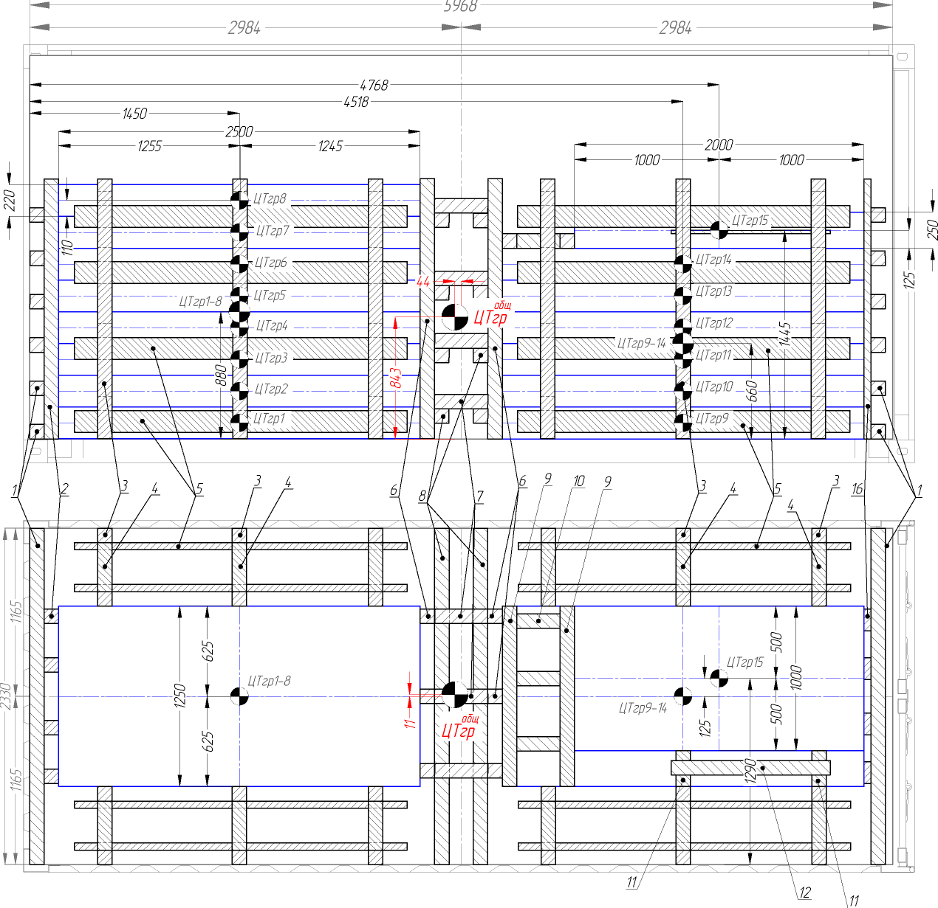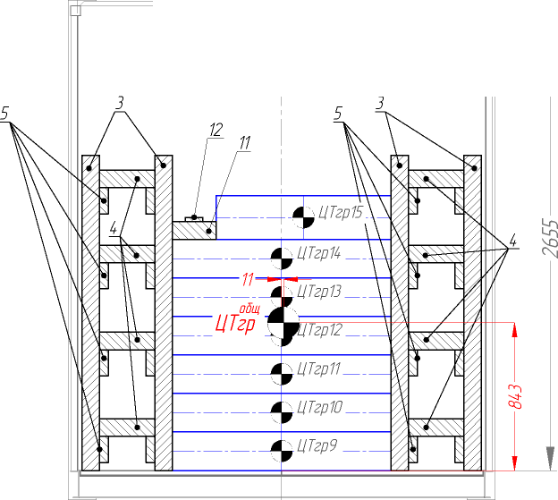

Notice: ЦТ – Load Center